Melt-in-your-Mouth Chuck Roast

Student’s Name
Department, University
Course Number and Name
Instructor’s Name
Date

Having a family of your own is usually the dream of everyone and thus when an opportunity of doing so comes knocking one should not play around with it. Alice and Tony have been presented with such an opportunity but before it is confirmed, both of them need the blessings of their parents. Alice who lives in Minneapolis has gotten the opportunity of hosting Tony’s parents who will be visiting from Oregon for dinner. This first meeting will be key to both Alice and Tony’s parents as far as building a lasting relationship is concerned. Everything is required to be perfect, no mediocrity should be entertained especially in cooking. Thus, inasmuch as she is not used to cooking, preparing something nice for her in-laws and hosting them will be helpful in laying grounds for the establishment of a perfect relationship between them. Thus, Alice has decided that she will be preparing melt-in-your-mouth chuck roast for dinner and hopes that it will be sumptuous and delicious to Tony’s parents.
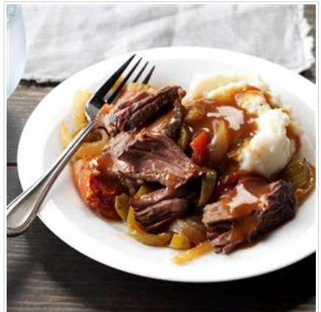
Melt-in-your-mouth chuck roast
Chuck roast comes mainly from the steer's shoulder section and the neck, ribs, and upper arm. It is a large part of the animal, and it is typically an affordable cut of meat. Some of the nutritional facts about the food include 31g protein, 26g carbohydrate, 98mg cholesterol, 15g fat, and 362 calories. Thus, the dinner will not be sumptuous but also rewarding health-wise. The ingredients for preparing melt-in-your-mouth chuck roast include:
- 1 can (14-1/2 ounces) Italian stewed tomatoes undrained
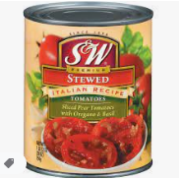

- ½ cup beef broth

- ½ cup ketchup
- 3 tablespoons brown sugar
- 2 tablespoons Worcestershire sauce
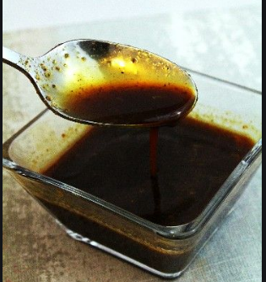
- 4 teaspoons prepared mustard
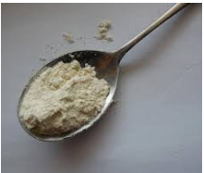
- 3 garlic cloves, minced
- 1 tablespoon soy sauce
- 2 teaspoons pepper (optional)
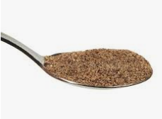
- ¼ teaspoon crushed red pepper flakes (optional)
- 1 large Onion, halved and sliced
- 1 medium green pepper, halved and sliced
- ½ celery rib chopped
- 1 boneless beef chuck roast (2 to 3 pounds)
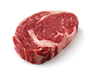
- ¼ cup cold water
- 3 tablespoon cornstarch.

In preparing the Melt-in-your-mouth chuck roast, the first step is the preparation of the chuck roast. In preparing it, Alice will first mix the first ten ingredients. In the second step, she will place the onions, green pepper, and celery in a 5-quartz slow cooker and place the roast over the top. She will then pour the Italian tomato mixture over the roast. Cook, covered, on low heat 5-6 hours until the meat is tender (TasteofHome, 2020). Remove roast and strain the cooking juices while reserving the vegetables. Transfer the juices to a small saucepan and skim the fat. In another bowl, add cornstarch and mix with water until smooth. Add the cooking juices into the mixture and stir until they are evenly mixed. Boil the mixture; for 1-2 minutes, cook and stir the cornstarch mixture until it thickened. The thickening of the mixture means it is ready to be served.
There is also the freeze option that Alice may consider using. She will place the sliced beef and vegetables topped with gravy in freezer containers to cool and freeze for the freeze option. She will partially thaw them in the refrigerator overnight. The next day she will remove it and heat through slowly in a covered saucepan, stirring gently while adding a little broth or water if necessary.
Based on the instruction, it will be vital that Alice starts her cooking earlier to avoid the last-minute rush. Preparing early will help her compose herself and concentrate on keenly following the cooking instructions to make a sumptuous meal for her in-laws.

References
TasteofHome. (2020, Sep 18). Melt-in-your-mouth Chuck roast. Retrieved from TasteofHome: https://www.tasteofhome.com/recipes/melt-in-your-mouth-chuck-roast/

